June 2026
Hawaiʻi National Guard Unit Public Affairs Representative Handbook
State Public Affairs Office
State of Hawaiʻi Department of Defense
Table of Contents
Executive Summary 3
About the Handbook 4
Appointing a UPAR 5
Supporting Your UPAR 6
Policy 7
Department of War Policy 7
OPSEC - Operational Security 7
Copyright and Fair Use of Your Products​ 8
UPAR Responsibilities 9
1. Public Affairs Preparedness 9
2. Public Affairs Liaison ​ 9
3. Take Photos, Write Captions and Get Published 9
4. Record Basic Video 9
5. Understanding Media and Social Media 9
1. Public Affairs Preparedness 10
PA Plan 10
Release Authority 1
Command Information and Internal Communication 2
Unit Newsletter 2
Social Media 2
2. Public Affairs Liaison ​ 1
3. Take Photos, Write Captions and Get Published 2
Taking Photos 2
Writing Captions 8
Getting Published 9
4. Record Basic Video 10
B-roll “Package” 10
5. Understanding Media and Social Media 11
Different Types of Media 11
Traditional Media 11
Special Circumstances 12
Social Media 12
Where Do PA Products Go 14
Social Media Accounts 14
HIDOD Newsletter - pūpūkahi 15
DVIDS 15
News Release and Media Advisory 15
UPAR VS PA Professionals 16
Getting Support 17
Contact Info 17
Additional Duty Appointment Sample Memo 19

Executive Summary
This handbook is organized into three key sections that provide guidance on the roles and responsibilities of the Unit Public Affairs Representative (UPAR).
The first section provides foundational information on how to use the handbook and how to select an effective UPAR. Commanders are encouraged to choose individuals who are knowledgeable, trustworthy and articulate, as they serve as the voice of the unit. To ensure success, commanders must also provide the time, mentorship and support necessary for UPARs to develop in the role. This section outlines the policy framework that governs public affairs, emphasizing the importance of sharing accurate information while maintaining professionalism and avoiding oversharing.
The second section outlines the five core UPAR responsibilities. These include:
- Public affairs preparedness through planning, goal setting and workload management
- Serving as the unit’s public affairs liaison and primary point of contact
- Capturing photos and written content
- Recording basic video through short, purposeful clips
- Understanding media and social media principles, including objectives and best practices
The final section clarifies the distinctions between a UPAR and a Public Affairs professional, highlighting the advanced expertise and responsibilities of the latter. It also identifies available support resources, key points of contact, and explains how UPAR-produced products are ultimately utilized.
Key takeaways for commanders are highlighted in green throughout the handbook for quick reference and ease of use.

About the Handbook
This handbook is designed to bring essential public affairs (PA) tasks into the UPAR realm. It serves as an entry point to help UPARs “break ground” in the field of PA. Readers are encouraged to establish relationships with the full-time Public Affairs Office (PAO) at State of Hawaiʻi Department of Defense Headquarters and to engage with other PA professionals across the Hawaiʻi National Guard (HING), including the 117th Mobile Public Affairs Detachment, Hawaiʻi Air National Guard Headquarters Public Affairs, and 154th Wing Public Affairs.
PA is an unavoidable and integral part of daily operations. It extends beyond interactions with news media and encompasses every engagement with unit members, leadership, and the community. Effective PA ensures unit messaging is aligned with higher headquarters and reinforces the HING’s credibility, trust and support within the community it serves.
The State PAO cannot be present at every drill, exercise, annual training event or real-world mission. Countless newsworthy moments occur at the unit level that would otherwise go undocumented. UPARs play a critical role in capturing these moments, telling the HING story, and sharing unit successes with local, national and global audiences.
The Adjutant General recognizes and actively supports the importance of PA planning. This emphasis begins at the senior leadership level and extends throughout the command. Strong PA practices are essential to building and maintaining public trust and goodwill, key enablers of mission success and overall unit readiness.
This handbook is intended to simplify PA efforts by providing practical guidance and reference material for PA efforts. While it does not replace the expertise of trained PA professionals, it equips UPARs with foundational knowledge and tools to perform their duties more effectively. The handbook emphasizes preparation, consistency and practice as the cornerstones of successful PA.
The following sections outline how commanders should select and support a UPAR, explain applicable PA policies and guidance and detail the five core competencies every UPAR is expected to develop. Additional resources are provided at the end of the handbook; however, the most valuable learning will come through hands-on experience and on-the-job training.

Appointing a UPAR
When appointing a UPAR, commanders should carefully consider the roles, responsibilities and expectations associated with the position. UPARs are entrusted to speak on behalf of the unit and to document missions through words and imagery; thoughtful selection directly impacts the quality and credibility of PA products.
Selection Criteria
- Select an individual familiar with the unit’s mission, leadership and culture
- Choose someone dependable with a proven record of performance
- Ensure the individual is organized, self-motivated and able to work independently
- Confirm the individual communicates clearly and professionally with unit members
- Ensure the individual has access to a smartphone with a camera and basic proficiency in its use
Appointment Considerations
- Appoint a UPAR willing to serve in the role (do not force assignment)
- Avoid assigning the newest Soldier or Airman solely to fill the position
- Commit to a minimum UPAR tenure of two years for continuity and effectiveness
- Schedule the UPAR to attend UPAR Training within the first year
The State PAO is responsible for training and tracking all HING UPARs. HING units are responsible for sending their appointed UPARs to required training and providing continued support throughout their term. Units will be notified if they become delinquent in appointing or maintaining a qualified UPAR.

Supporting Your UPAR
For a UPAR to be effective, commanders and units must provide two essential elements: time and support. Both are critical to enabling successful PA outcomes.
Time
Time is the single most important resource a commander can provide a UPAR. Commanders should allocate time to meet with the UPAR to develop and initiate the unit’s PA plan and to align expectations, priorities and commander’s intent.
UPARs require an initial adjustment period to become proficient in their role. While training provides foundational knowledge, skill development occurs through hands-on experience. Commanders should anticipate and allow time for learning and growth as the UPAR becomes more efficient.
UPARs must balance PA duties with their primary mission responsibilities.
PA tasks extend beyond the event itself. UPARs need adequate time to plan, capture content and complete post-event production and submission. This is especially important for major activities such as promotions, retirements or change of command ceremonies. This workload should be accounted for during PA planning, including the final step of the process — submitting products to the State PAO.
Support
Command support must be visible and understood across the unit. Guardsmen should know who the UPAR is and recognize that the commander actively supports their role. UPARs should be included in appropriate staff meetings, receive training schedules and be involved early in the planning of unit events.
Effective UPARs remain informed about unit activities. Commanders should ensure the UPAR’s name and role are clearly communicated, posted on unit bulletin boards, mentioned during pre-drill meetings and reinforced by encouraging unit members to coordinate with the UPAR on potential newsworthy events.
Resource needs will vary based on goals and output. When a UPAR is tasked with producing products such as a unit newsletter, commanders should provide clear information; access to a computer; and the ability to upload and manage photos and content. UPARs should also receive assistance with content collection and development, they cannot accomplish these tasks alone.
Smartphone cameras are acceptable tools for UPARs, and additional technical or professional assistance is available through the State PAO when needed.

Policy
UPARs must operate within established Department of War policies that govern the release of information. Understanding these policies is essential to maintaining transparency, protecting sensitive information and preserving public trust.

Department of War Policy
Effective communication is a core responsibility of all government organizations. DOW policy promotes the free flow of general and military information to the public without censorship or propaganda. Information will not be classified or withheld to protect the government from criticism or embarrassment.
Information is withheld only when its release would adversely affect national security, compromise operational security, threaten the safety or privacy of Service members or when restricted by law or regulation. Even unclassified information, when combined or released without context, can unintentionally reveal sensitive details. For this reason, all information intended for public release must undergo a security and policy review, conducted by PA professionals.
Some key points from the DOW policy:
- The obligation to provide the public about major programs may require detailed PA planning and coordination within the DOW and other agencies​.
- Propaganda has no place in PA.
- Information released must be accurate, timely and appropriate for the intended audience.
- PA efforts should increase awareness of the organization’s mission, goals, policies and programs.
- A good PA program helps to foster community relations and can build ​goodwill.
- Accurate information should be released quickly, efficiently and through multiple communication platforms​.
- We are accountable to taxpayers and rely on their support.
- Personal information about Service members must be protected. The Privacy Act limits what information may be released about individuals.

OPSEC - Operational Security
Under no circumstances may classified information be released. UPARs must not comment on matters that are or may be, classified. If information requested is known to be classified, the UPAR should clearly state that they cannot comment. If there is uncertainty, the UPAR should pause and seek guidance before responding. When in doubt, the appropriate response is: “You need to speak with the PAO.”
All personnel share responsibility for safeguarding sensitive information and practicing security at the source.

Key points to keep in mind include:
- Do not disclose the exact number of troops, exact times of departure, radio frequencies, which vehicles are mission ready, what route a unit will take, etc.
- Do not disclose social security numbers, birth dates, contact information, etc.
- OPSEC applies across all platforms, including media engagements, email, social media, and conversations with family and friends.
- Preventing unauthorized disclosure protects mission effectiveness and Service member safety.
- For examples of what can be said, please ask PAO

Copyright and Fair Use of Your Products​
PA products created by Service members using government equipment, on government time, or while in a duty status are not eligible for personal copyright. These products are considered government works and belong to the U.S. Government.

UPAR Responsibilities
A UPAR has five core responsibilities. Each section of this handbook explores these areas in detail, outlining expectations and providing examples for reference.

Public Affairs Preparedness
PA preparedness begins with deliberate planning and coordination between the UPAR and unit commander to ensure coverage aligns with the commander’s intent. UPARs should plan to document key events and create a written PA plan outlining coverage priorities. Effective command information, through newsletters, briefings, flyers and internal platforms, may also be supported by the UPAR.

Public Affairs Liaison ​
A UPAR serves as a liaison, facilitating communication and coordination between the unit and higher-level Public Affairs elements acting as the unit’s primary point of contact for all PA matters. To be effective, UPARs must develop a strong understanding of their unit’s mission, structure and leadership, becoming the subject matter expert on their unit.

Take Photos, Write Captions and Get Published
The UPAR’s primary responsibility is to capture high-quality photos, write clear and accurate captions and submit content to higher Public Affairs elements to share the HING story across multiple platforms. Effective photography requires strong composition, focus, proper lighting, attention to background, and a variety of shot types to tell a complete story. Captions must clearly explain who, what, when, where, why and if possible, how. UPARs must confirm release authority and submit their best photos and captions regularly for review and distribution.

Record Basic Video
Recording basic video builds on photography fundamentals but with additional considerations to produce content. UPARs are expected to capture short standalone clips or B-roll, with video consisting of steady shots under 15 seconds, attention to lighting, varied angles and distances, in both horizontal and vertical formats. A strong B-roll package includes multiple short clips along with cut-aways for editors to create smooth, visually engaging stories.

Understanding Media and Social Media
Understanding traditional and social media is essential for UPARs to comprehend the framework of PA products. Media today includes print, radio, television, digital platforms and social media, each with different goals. Traditional media plays a vital role in a democratic society with timing, accuracy and responsiveness being import for reporting. Social media, meanwhile, enables real-time communication, storytelling, outreach, and engagement across platforms such as Facebook, Instagram, X, LinkedIn and YouTube, making it an important tool for connecting with internal and external audiences.

Public Affairs Preparedness
PA preparedness begins with deliberate planning. The UPAR should be prepared to cover unit participation in:

- Community projects
- Promotions
- Award ceremonies
- Changes of command/responsibility
- Re-enlistments
- Yellow Ribbon events
- Retirement ceremonies
- Family Readiness events
- Holiday functions
- Training
- Exercises

PA Plan
UPARs should meet early with their unit commander to establish a unit PA plan aligned with commander’s intent. Planning should start with a review of the annual training and drill schedules, identifying key training events, exercises and activities that may be newsworthy. UPARs should proactively pitch coverage ideas and work with the commander to finalize priorities.
Preparedness means having a schedule. For big, planned events, the UPAR should identify a point of contact, gather essential details and coordinate logistics in advance. Large-scale events, such as annual training or major exercises often generate significant content opportunities. Reviewing other units’ PA products and social media can help UPARs identify different ideas.
A PA plan should be written, revisited and revised as needed. Maintaining flexibility allows the plan to adapt to emerging missions, changing priorities, or unplanned opportunities. A well-maintained plan sets the conditions for success.
Example PA Plan
September | Social Media Post - Weapons qualifications  - Take photos, get best scores and new shooters​  - Write caption  - Send to State PAO for social media posting
October | Coordinate with higher PA, about new equipment  - Reach out to contact with story idea and details (5 Ws)  Dec Newsletter  - Start designing layout and looking at past photos for story ideas
November | Dec Newsletter  - Draft content and pics  - Get Commander to write a column​  Holiday party  - Contact committee to get event details
December | Holiday party  - Take photo  - Write a story  - Add to newsletter  Dec Newsletter  - Do final draft  - Get commander approval  - Distribute newsletter
Annual Training | Social Media Post - Soldier’s first AT  - Take photos  - Write caption  - Send to State PAO for social media posting

What should come out of a PA Plan?
- Commander’s intent and objectives​.
- What will be covered by UPAR during drills and annual training​.
- When to request PAO​ support.
- Expectations and evaluation of content produced.
- Command commitment to time and resources

Release Authority
Release authority, the approval to publish photos, captions or newsletters, is a critical component of PA. At the unit level, the commander serves as the UPAR’s initial release authority and may provide approval for internal products such as unit newsletters. UPARs must keep commanders informed of planned coverage and products.
During real world events, exercises or training events, establish communication with the higher PA element — 117th MPAD or 154th Wing, as they will approve all products and be the release authority.
The State PAO will be your full-time higher PA element. The State PAO serves as the PA subject matter expert. During State Active Duty missions there may be a HING Task Force PAO, but you can always contact the State PAO.
For all official social media posts, release authority belongs to State PAO and during exercises or deployments the first PA professional in your chain of command.

Command Information and Internal Communication
Effective command information strengthens internal cooperation, supports mission execution, boosts morale, improves quality of life, and contributes to retention.
Command information could be presented as:

- A newsletter
- A flyer
- A briefing
- A bulletin board
- An internal slideshow or collage

Unit Newsletter
A unit newsletter is one of the most effective tools for reaching Guardsmen and their families. Newsletters should be informal, consistent and supported by the commander. While UPARs can provide content and assist with development, newsletters are a unit responsibility and should be managed by a designated working group, not solely the UPAR.
The unit newsletter may include:
- Comments from the commander and senior noncommissioned officers
- Latest promotions and awards
- Training schedules and important contacts
- Family-related information (PX/BX, benefits, pay, upcoming events)
- Photos with captions
- Relevant updates from Big Army, NGB, NGAUS, HING
Newsletter best practices
- Use existing templates (Word, Canva, or similar tools)
- Keep design and messaging simple
- Avoid overly casual or “clever” language
- Start small and then increase amount of content and design over time
- Include higher headquarters on distribution lists
- Plan publication timelines around major events
- Request assistance from higher PA elements or the State PAO when needed

Social Media
Units may maintain unofficial social media accounts for internal communication. These accounts must be clearly labeled as unofficial, restricted to closed or private audiences, and not accessible to the general public.

Public Affairs Liaison ​
A liaison facilitates communication and coordination between organizations. For a UPAR, this role involves serving as the primary PA link between the unit commander and higher-level PA elements. The UPAR also functions as the point of contact for all PA-related matters within the unit.
UPARs should develop expertise in their unit’s operations, structure and leadership. This knowledge allows them to provide informed guidance to the commander and support higher-level PA efforts. Building this expertise and gaining the trust of leadership is a gradual process, requiring experience, reliability and consistent performance.
UPARs may have information being “pulled” and “pushed” from them:
- Pulled: Requesting information or guidance from UPARs by higher PA elements
- Pushed: Forwarding content such as stories, photos or videos to higher PA elements for distribution and publication
UPARs must maintain situational awareness and immediately notify the State PAO (with confirmation from unit leadership) of any events or incidents that could attract national or international media attention, including accidents or investigations.
Through their liaison role, UPARs help ensure unit activities are accurately represented, integrated into broader PA efforts, and aligned with commander intent and organizational objectives.

Take Photos, Write Captions and Get Published
The primary responsibility of a UPAR is to capture quality imagery, write informative captions, and submit content to the higher PA element. These products allow the State PAO and higher PA elements to tell the HING story across multiple platforms
Content opportunities:
- State emergency activation
- Unusual or noteworthy training
- Change to equipment, force structure or mission
- Visits by dignitaries or well-known personalities
- Public service or charitable projects
- Drug demand reduction programs
- Major awards, honors or individual achievements
- open house and ceremonies
- Interesting new equipment or aircraft
- Overseas deployments for training
- Cost saving solutions
- Events that have an impact on the local environment
- Annual training for your unit
- Officer and Noncommissioned Officer academy graduations
- Presentation of awards and decorations to your unit or individual members
- Construction or significant remodeling/repair of military facilities in your area
- Changes to recruiting/retention benefits

Taking Photos
Good photographs meet certain standards, be in focus, grab your attention and a have good range of contrasts, not looking washed out, the colors should be rich and vivid.
A photo serves the purpose of illustrating the story you are telling. If your story is about a change of command, a good head and shoulders picture of a new commander illustrates the story, better than a group picture of the unit's senior leadership, or the customary "passing the flag" picture. If your unit has received new equipment, take photos of the equipment in action, not resting on the armory floor.
Any subject (a person, equipment) or training area can be photographed in an unlimited number of ways. Each picture will give a different impression of the subject. Close-ups can be powerful images. Taking a photo at an unusual time or day or during stormy weather can add impact to a photograph. A good photographer needs to develop their ability to observe the action and decide how best to tell a story with one or more photographs. Be willing to experiment, to practice and ask for help from professionals.

When you’re taking photos remember:
- Get as close as possible to the action, but do not interfere or restrict movement with your presence. Don’t get in the way of the mission or compromise safety in the process​. Practice doing a run through scenario of “getting close to the action.”
- Pictures should be in focus. To focus on your subject with a smart phone camera tap on the screen where you want to focus, such as people’s faces.
- Take multiple photos, you can always delete extras later, but you can’t recreate a moment. Burst mode is a useful feature on your phone to take many photos at once. Review your photos when the event is over, you don’t want to miss the perfect moment because you’re looking back at the images​.
- Prepare ahead of time, by charging your phone and having enough storage space for photos and video.
General tips when taking photos:
- Rule of thirds - gridlines help with composition of photo, by showing the spacing. Divide any composition into thirds, vertically and horizontally, and then place the key elements of your image along these lines or at the junctions of them. The arrangement achieved will be more interesting, pleasing and dynamic.
- Look for informal or unrehearsed scenes, posed pictures look "posed". Since you can't always take pictures without others noticing, spend a few moments with your subjects to put them at ease.
- Avoid taking too many shaka photos, some are fine but no more than two for any event.
- Beware of things in the background of your photos. Is a tree branch or howitzer barrel "growing" out of the back of the head of your subject? Be aware that it is hard to see troops in camouflaged uniforms when they are posed against trees and shrubs. Shoot from a lower angle and make the sky your background, or search for other viewpoints that reduce the chance your subjects will blend into the background too much.
- Take a few moments for a check of your subjects. Are they in proper military uniform? Are they working with equipment or weapons in an approved and safe manner? Do they have on all the PPE that they are required to have on?
- Don't crowd a photograph with people or subjects.
- In sizing the photo, you want to be able to see faces and patches.
- Every photograph must have a caption. Take care to ensure that names are spelled correctly and that equipment or the action in the photo is adequately described. Keep a note pad on hand to have people write in their rank, name, unit and MOS. After the photo take a picture of the names to track who’s who. Get the 5W’s (Who, what, why, when and where)
- During ceremonies and formal events remember that people may be behind you or to the side of you. During these situations try not to photobomb other photographers or videographers. Attend the rehearsal to figure out placement and plan some shots you’d like to take.
- UPARs are not authorized to manipulate or alter photos
Photo Angles
Eye Level​ | A smartphone is placed at the same height as the eyes of the subject in your frame. | 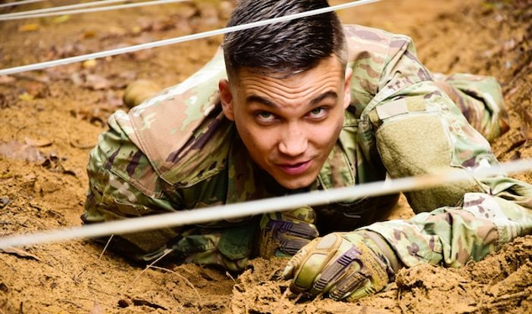
Top View​ | Where the smartphone looks down on the subject. | 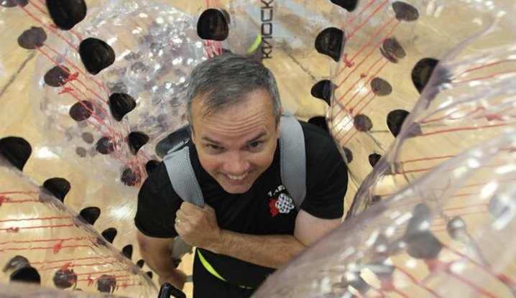
High Angle​ | Placing the smartphone high about your head angled down on your subject. | 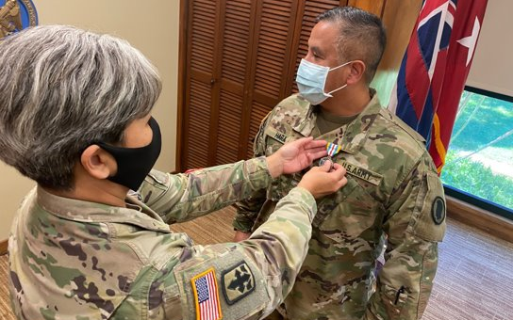
Framed View​ /Hidden View | Can be set and framed in any shot size you like, if there is only one character featured within the frame. | 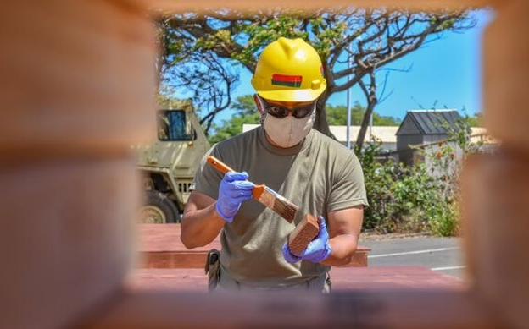
Off-Center​ | Space in front of the subject. | 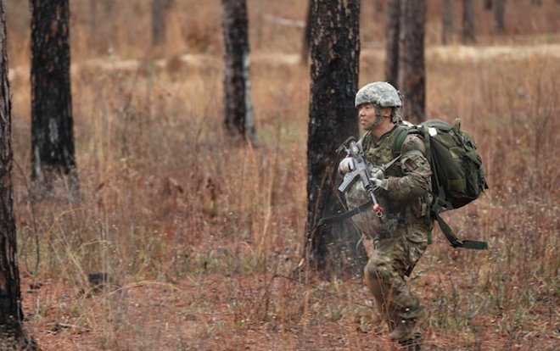
Low Angle | Conveys several emotions or feelings about the subject in the frame. | 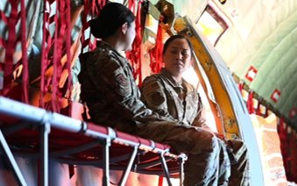
Action | Capturing the subject in motion. | 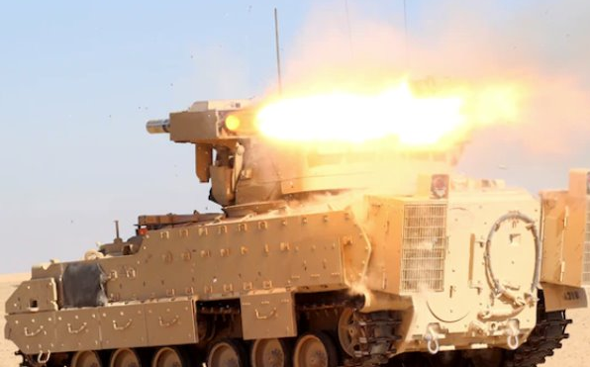
​ Posed | Constructed by the photographer and are often controlled. | 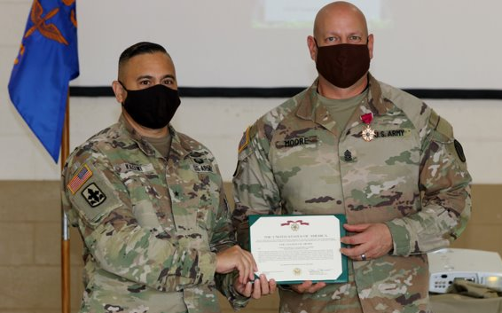
Focal Point | The point at which all elements or aspects converge; center of activity or attention. | 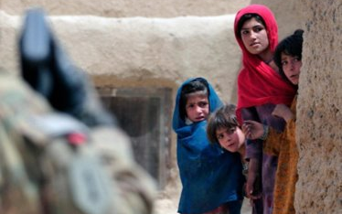
Candid | A photograph captured without creating a posed appearance. | 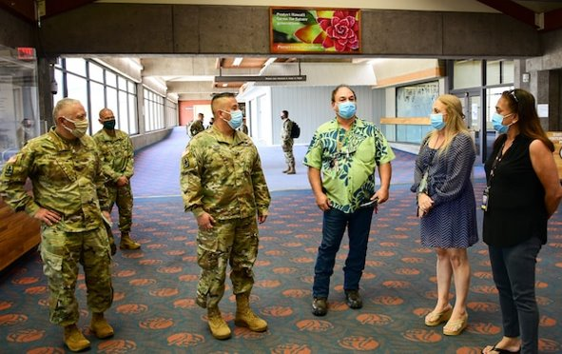

Tips for taking pictures with a smartphone:
- Make sure your phone doesn’t have geo tagging on, keep OPSEC in mind.
- High Dynamic Range, a HDR photo is created by balancing the shadows and highlights of an image so that neither is being favored or ignored. This can help with situations that are low light.
- Turn off camera sound, so there’s no noise when taking photos.
- If possible, use airplane mode when taking photos as it eliminates a lot of concerns.
- You can add gridlines to the screen of your smartphone under settings (rule of thirds).
- Turn-off any “live” photo feature that your phone may have.

Series of photos
A series of photos can tell a story by varying the angle and the distance. Photographers should take a variety of shots when covering an event.
- Establishing shots establish the scene and show the reader the big picture. There does not need to be identifiable people in these shots.
- Long shots show the scene and several people placement within it.
- Medium shots show one or two clearly identifiable people doing something. Try to get at least a three-quarters view of the person and make sure you can see the eyes. Most of your shots should be medium shots.
- Close-ups focus on the center of the action and include only one person. When fitting the person and action into the frame, called cropping, make sure you do not cut them off at the joints. For examples if showing the face, cut above the eyes and below the mouth. If showing the hands at work, cut in the middle of the hand or include the wrists.

Establishing Shot  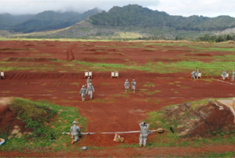 | Long Shot  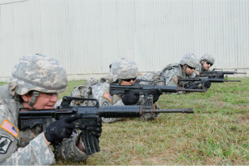
Medium Shot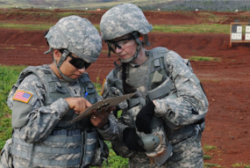 | Close-Up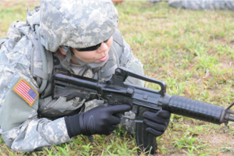

Writing Captions
Captions explain the photo and its significance, a well-written caption complements the image and helps convey the story to the audience. Captions should be short and clear, typically 1-3 sentences, they can highlight technical information.
Basic Elements of a Caption
Who | Who is in the photo? Who is the subject of the photo?​  Full ID (Rank, Name, Unit and MOS) If less than three people in photo​.
What | What is in the photo? What is the action taking place? ​
When | When is the action taking place? (date, training event)​
Where | Where is the action taking place? (geographic location)​
Why | Why is the action taking place? Why does it matter?​
Byline | Photo credit
How | If possible, explain how?

Example Caption
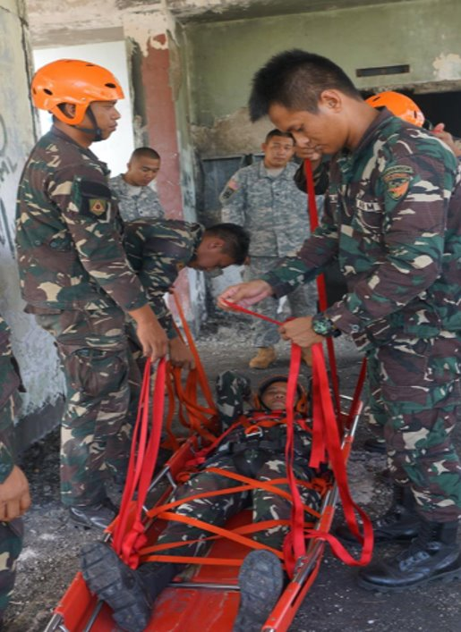
Members of the Armed Forces of the Philippines, 525th Engineers, demonstrate patient packaging during a subject matter expert exchange in support of Balikatan 2017 at Fort Magsaysay in Santa Rosa, Nueva Ecija, May 7, 2017. These skills ensure that first responders and military members can secure and remove victims during a real-life crisis. Balikatan is an annual U.S.-Philippine bilateral military exercise focused on a variety of missions, including humanitarian assistance, disaster relief, and counterterrorism. (U.S. Air Force photo by Tech. Sgt. Andrew L. Jackson)​

Getting Published
After taking photos and writing captions, consider who has the release authority. During drill, annual training or exercises, it’s the State PAO. ​During deployment it could be a brigade PA professional or higher PA elements may give release authority​. During exercises, UPARs or commanders should ask who has release authority.
To share the HING story, submit 3-5 of your best photos with captions to State PAO at least once a quarter. This will allow the photos and captions to get published at a higher level, such as in the HIDOD Newsletter, HING social media or the local news.
An online form has been set up on the State of Hawaii Department of Defense website for UPARs to upload photos and captions. The State PAO will review, approve and provide guidance if content does not meet publishing standards.

Record Basic Video
Recording video shares many principles with photography, but it also has unique considerations. UPARs are expected to capture short videos that can be used by the State PAO or other higher PA elements for news stories, social media, training materials or internal communications.
- Standalone videos can be edited and published as is
- B-roll is supplemental footage that provides context, visual interest, and coverage when media cannot attend events. It allows editors to assemble complete news stories using footage of unit activities.
Tips for shooting video:
- Keep individual shots 15 seconds or less
- Hold the camera steady; use a tripod or a stable surface (“lean-to” method) when possible
- Don’t zoom in or out, physically move or walk closer
- Monitor lighting to ensure subjects are clearly visible
- Record a mix of horizontal and vertical views
- Record from a variety of angles and distances
- Look out for people who may be video bombing the footage
- Minimize background noise; avoid talking, sneezes, or coughs during recording
- Review videos before sending to ensure correct content and quality

B-roll “Package”
A B-roll package should provide editors with flexible content to construct a story:
- Multiple short clips, each under 15 seconds.
- Variety of angles and distances: establishing shots, medium shots, and close-ups.
Cut-aways: Insert additional shots between primary footage to smooth transitions. Examples include close-ups of rank insignia, nameplates, event decorations, or other contextual details. For instance, instead of cutting directly from a speaker’s close-up to a wide shot of the audience, insert a cut-away of a nameplate or emblem. This helps editors create a cohesive, visually appealing story.

Understanding Media and Social Media
A key part of the UPAR role is understanding how traditional media and social media work, and how to help ensure the unit’s message is communicated accurately and effectively. While UPARs are unlikely to conduct formal media interviews, they may interact with smedia or be asked questions by journalists.

Different Types of Media
Media today spans print, radio, TV, digital and social media, with digital platforms dominating public consumption. Understanding each platform’s purpose and goals helps UPARs support PA professionals in their mission.
Media is looking for:
TV | They want a great video; it can be provided during visit, or you can have b-roll already up on DVIDS​.
Radio | They want some natural sounding sound bites and a good interview
Print | They want one or two great pictures of action that matches the story​
Digital | “Click bait” quality video, photo or headlines

Traditional Media
Reporters have a job to do, their stories and pictures serve an important function in our democratic society. The first item in our nation's Bill of Rights deals with freedom of the press and which is a cherished freedom. Traditional media would be considered Newspapers, Magazines, TV reporters and journalists.
Key facts to know about traditional media
- Reporters have bosses to serve and often work in a competitive marketplace. To be successful, they must be accurate and fast. Their eagerness to work quickly doesn't always mesh with the military's careful way of doing business, but a smart PA satisfy the media's requirements for speed and accuracy while at the same time protecting the best interests of the HING.
- Timing is everything. For TV media outlets, they like to be on-site for less than an hour as they must shoot and edit the video, write the story before the first newscast, which can be as early as 1600. If you back plan from there, they need to be at their station by 1400 or 1500 to work that story. Meaning your event needs to be done an hour prior. So, if you really want media to attend an event, make it early and convenient. Newspaper and web-based media have a little more flexibility.
- Reporters are eager to learn about new things, experience new situations and meet interesting people. All these factors contribute to their mission of informing the public. Harness this natural curiosity to your unit's advantage.
It is important to keep in mind the spirit of a DOW document “the Principles of Information”. These published principles require that everyone in the military must maintain open, honest and fair dealings with civilian journalists. Information may not be withheld from a reporter who asks for it merely because the information may be embarrassing to the military.
The Assistant to the Secretary of War for PA has the primary responsibility for carrying out the commitment represented by these principles. The Principles of Information are codified as enclosure (2) to Department of Defense Directive 5122.5 of Sept. 27, 2000.

Special Circumstances
If a serious incident takes place involving members of your unit, or something happens in your area involving HING property or equipment, work with your chain of command to ensure that the State PAO is notified immediately. If an accident involves serious injury, death or significant loss of property, the moment you finish calling for help from the police and/or fire departments, and the commander updates his leadership chain, the UPAR should begin the process of notifying State PAO.
By notifying State PAO immediately, you engage the horsepower of higher headquarters. Rely on the full-time PA Officer to take over the PA mission and stand by to help.
On occasion, a unit commander may find themselves responding to a reporter's questions that deal with accidents, criminal matters or political activity. In situations where you are waiting for assistance, here are suggestions to aid your efforts:
- “I am not authorized to speak about this topic. I would refer you to my PAO.”
- Names of dead or injured victims must not be released until the victims' next of kin have been properly notified. Use this statement: "The names of the victims are being withheld pending notification of next of kin."
- Do not speculate about the cause of an accident, an investigation will determine the cause. Don’t deny the obvious, for example if an aircraft has crashed and burned, say that a crash and fire have taken place, don't speculate as to the reasons why.

Social Media
Social media refers to digital platforms and applications that allow people to create, share and interact with content in real time. Its primary purpose is to connect individuals, organizations, and communities by enabling communication, information sharing, storytelling, networking and engagement across broad audiences. Social media is used for personal connection, professional networking, news distribution, marketing, public outreach and community building.
Common examples include Facebook for community interaction, Instagram for photo and video sharing, X (formerly Twitter) for real-time updates and conversations, LinkedIn for professional networking and YouTube for video content.
Social media has fundamentally changed the media landscape by shifting the flow of information from a one-way, traditional broadcast model to a fast, interactive and user-driven environment. In the past, news and information were primarily controlled by established media outlets such as newspapers, television, and radio. Today, individuals, organizations, and even eyewitnesses can publish content instantly, reaching global audiences without going through traditional gatekeepers.
Social media has:
- Accelerated the news cycle/ shorten attention spans
- Increased public engagement through comments
- Changed stories by providing feedback and dialogue
- Increased the spread of mis/dis/mal-information
- Increased the pressure to respond quickly potentially compromising accuracy and credibility

Where Do PA Products Go
With a photo and caption the State PAO can use it many ways to tell the Guard story. It can be sent to local media, published on social media, used in high-level slideshows, and if it’s good enough, sent to the Defense Visual Information Distribution Service (DVIDS). On the DVIDS website, media and the public can join and download military imagery, videos and stories for free, to use for their newscasts or publications.
Levels of PA Information Sharing
Level 1 | Unit level | Examples: Unit newsletter
Level 3 | State PAO | Examples: HIARNG, HIANG, TAG, DAG, CSEL social media, HIDOD PowerPoints, Pupukahi newsletters, DVIDS or news releases
Level 4 | Local or National Media | Examples: Any media outlet (TV, online, newspaper), DOW, NGB, INDOPACOM, Big Army or Big Air Force, USARPAC, PACAF

Social Media Accounts
- Hawaiʻi Adjutant General
  - https://www.facebook.com/taghawaii/
  - https://twitter.com/HawaiiTAG
  - https://www.instagram.com/tagofhawaii/
  - https://www.youtube.com/@HI_DOD_PA
  - https://www.linkedin.com/company/hidod/
- Hawaiʻi Deputy Adjutant General
  - https://www.facebook.com/daghawaii
- Hawaiʻi National Guard Command Senior Enlisted Leader
  - https://www.facebook.com/HawaiiNationalGuardSeniorEnlistedLeader/
- Hawaiʻi Army National Guard
  - https://www.facebook.com/HIARNG/
  - https://www.instagram.com/hawaiiarmynationalguard/
  - https://www.linkedin.com/company/hiarng
- 11th Army Band
  - https://www.facebook.com/111thArmyBand/
  - https://www.instagram.com/111tharmyband/
- Hawaiʻi Air National Guard
  - https://www.facebook.com/hawaiiairguard/
  - https://www.instagram.com/hawaiiairnationalguard/
  - https://www.linkedin.com/company/hiang
  - https://x.com/HiAirGuard

HIDOD Newsletter - pūpūkahi
The State of Hawaiʻi Department of Defense publishes a bi-monthly newsletter called the pūpūkahi which highlights information from the five divisions of the department.
- https://dod.hawaii.gov/newsletter/pupukahi/

DVIDS
Defense Visual Information Distribution Service (DVIDS) is the Department of War's public service that connects the military with media and the public by providing free, high-quality photos, videos and news directly from service members and operations worldwide, covering everything from combat to humanitarian aid. It serves as a crucial resource for journalists, content creators, and anyone interested in military affairs, offering searchable archives and live interview opportunities.
- State of Hawaiʻi Department of Defense, Public Affairs Office
- 117th Mobile Public Affairs Detachment, Hawaiʻi Army National Guard
- 154th Wing Public Affairs, Hawaiʻi Air National Guard
- Hawaiʻi Air National Guard Headquarters

News Release and Media Advisory
A news release is an official, written communication from an organization directed at the news media to announce something newsworthy, such as product launches, events, or personnel changes. It uses a structured format to deliver key facts (who, what, when, where, why) for public dissemination. UPARs could provide some of the specific unit information for a news release. They are normally written and published by State PAO.
Media advisories are used to invite media to an event. Like news releases, UPARs could supply information to the State PAO.
- News release: https://dod.hawaii.gov/news/?yr=&mo=&cat=98
- Media advisory: https://dod.hawaii.gov/blog/category/media-advisory/

UPAR VS PA Professionals
UPARs are not PA professionals. However, they can assist the PA professionals within the chain of command​. The UPARs main goal is to take a photo and write a caption, everything beyond that is a bonus. PAO professionals appreciate the UPAR’s time and effort put into the role. UPARs should learn as much as possible, but they can always reach out to State PAO for help. The UPAR role is valuable to the commander and can help make the unit a better place. Commanders should protect their UPARs from mission creep and not pile on every communication idea on them.
What does a UPAR do:
- They are knowledgeable in PA preparedness, from making a plan and executing​.
- They are the liaison between the unit and higher PAO elements.
- They take photos and write captions, which is their most important responsibility.
- They record basic videos
- They have an understanding of the media and social media landscape
What does a PA professionals do:
- They plan and execute TAG’s and higher PA objectives​.
- They provide PA support to newsworthy events, usually BDE or higher​.
- They take photos, writes captions and stories and post to DVIDS​ in a timely manner.
- They facilitate engagements with media ( press conferences, interviews etc.)
- They prepare and publish news releases, media advisories and prepare spokespersons.
- They create stories, share photos and captions on social media​.
- They can compose talking points and command messages​. They help write the PA annex for operations and exercises.
- They do the initial engagement with the media and respond with effective and approved messaging.
- They are honest and share good and bad news. “Maximum exposure. Minimum delay.”

Getting Support
The 117th Mobile Public Affairs Detachment or the 154th Wing Public Affairs can provide:
- Support to the state's overall PA program
- Support to units
- News release support
- Still photo support and video capability
- Media escort
- Subject matter expert prep
- Train non-PA units on basics of PA
- On-site assistance during emergencies
The State PAO should be able to assist you with the following:
- Coordination of a PA plan
- Publish web pages
- Speech writing for leaders
- Media plan, media research and media visits
- On-site PA support during an emergency
- Consult on quality of work

Contact Info
Hawaii Public Affairs Office
Mainline: 808-441-7000
dod.pao.all@hawaii.gov
Director, Public Affairs  Retired Maj. Jeff Hickman | jeffrey.d.hickman@hawaii.gov | 808-369-3518
Public Affairs Specialist  Ms. Rachel Blaire | rachel.s.blaire.civ@army.mil  rachel.s.blaire@hawaii.gov | 808-369-3520
Information Specialist III  Mr. Ruben Duldulao | ruben.duldulao@hawaii.gov | 808-369-3517
Photojournalist/Videographer  Retired Master Sgt. Andrew Jackson | andrew.l.jackson@hawaii.gov | 808-369-3521
117th Mobile Public Affairs
Recruiting & Retention Battalion
Public Affairs  Sgt. 1st Class Thomas Foster | thomas.a.foster12.mil@army.mil | 808-672-1690
Headquarters 154th Wing (154WG)
Public Affairs  Master Sgt. Mysti Bicoy | mysti.bicoy.1@us.af.mil | 808-789-0419

Additional Duty Appointment Sample Memo

NGHI-TAG 29 April 2026

MEMORANDUM FOR RECORD
SUBJECT: Area of Special Emphasis (Additional Duty Appointment) – Public Affairs
Representative (UPAR)

- Effective 1 May 2021, the below named individual(s) is appointed as indicated:
  - Primary: HARRINGTON, THADDEUS G., SSG, 117TH MPAD
  - Contact: 808-369-3520, Thaddeus.g.harrington.mil@mail.mil
- AUTHORITY: AR 360-1, Para 2-3
- PURPOSE: To assume the responsibilities for the administration of the unit’s public affairs program, providing support to the commander IAW the HIARNG UPAR Handbook, AR 360-1, and NG PAM 360-5.
- PERIOD: Until officially relieved or released from appointment.
- SPECIAL INSTRUCTIONS: Capture, publish, and submit captions, photos and videos relevant to the unit missions. Individual(s) will become familiar with applicable regulations(s), attend yearly UPAR training event, and perform duty as required. This duty appointment supersedes all others.
- POC for this action is SFC Michael Johnson at XXX-XXX-XXXX, Michael.j.johnson@mail.mil

KIPP J. WARD
LTC, FA HIARNG
Commanding

DISTRIBUTION:
1 – Individual Concerned
1 – Addl Duty Binder
1 – Unit File
1 – Brigade EOA

