The Judd Family and the Hawai‘i National Guard
Stephen Lum researched and wrote the following article about the Judd family and their connections with the Hawai‘i National Guard. Steve retired from the Hawaii Army National Guard and continues to work in the State Department of Defense’s public affairs office. His had worked on annual reports, the pūpūkahi and other documents over the years. His research produced in depth articles about the Hawai‘i National Guard and Guard members.

Hawai‘i’s seventh governor, Governor Lawrence McCully Judd, has a storied biography that links him to the history of the National Guard and Hawai‘i.
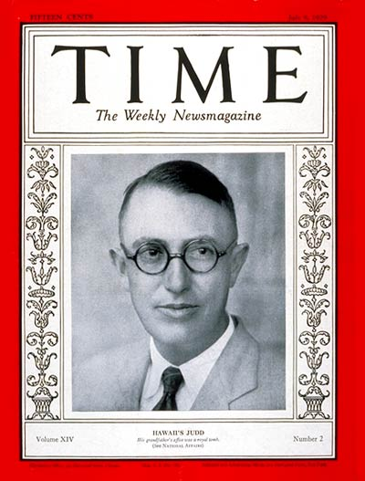
He was born in 1887, in Honolulu, the last of nine children of Hawai‘i Supreme Court Chief Justice Albert Francis and Agnes Hall Boyd Judd. Albert named him after his colleague, First Associate Justice Lawrence McCully (appointed by King Kalākaua). His grandfather is Dr. Geritt Parmele Judd, who came to the islands as a missionary physician and later served as an advisor to Kamehameha III. He is also a descendant of Thomas Hastings, who came from England to the Massachusetts Bay Colony in 1634.
Education and career
Judd graduated from Punahou Preparatory School (Geritt was one of the founding fathers of the school for missionaries’ children) in 1905, and attended the University of Pennsylvania. He married Florence Hackett and had four children. After working on the continental United States for a few years, he returned to Hawai‘i and worked at Alexander & Baldwin and Theo H. Davis & Co., Ltd.
Governor Judd on the cover of Time magazine, July 7, 1929
His military career began in 1915, when he enlisted in the National Guard of Hawai‘i as a private when World War I began. He career included:
- Private (Company B, 1st Battalion, 1st Hawaiian Infantry)
- Second lieutenant (battalion quartermaster)
- First lieutenant and captain (machine gun company executive officer and commander)
- Major (2nd Battalion, 1st Hawaiian Infantry commander)
- Lieutenant colonel/aide l de l camp to the Brig. Gen. Samuel I. Johnson, 1st Brigade
- Commander/adjutant general, colonel (298th Infantry commander)
- Commander-in-chief of the National Guard of Hawai‘i, as the governor of Hawai‘i
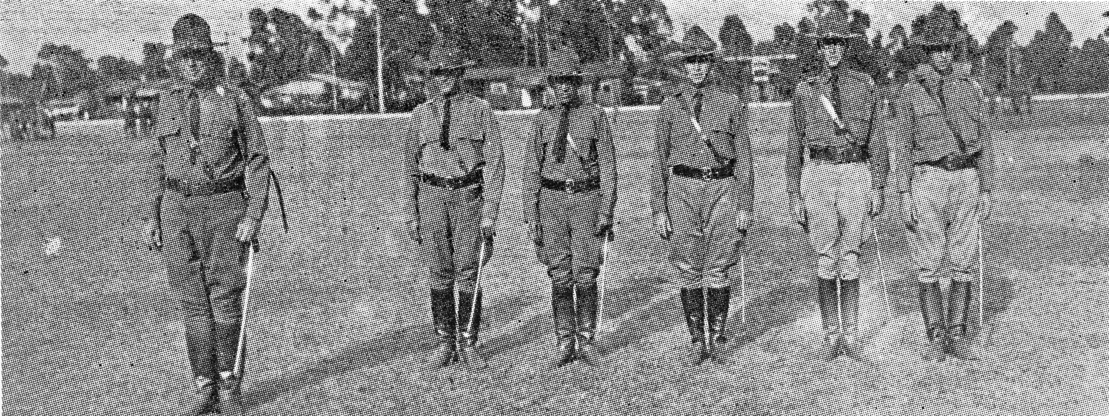
Col Judd and his staff, Spring 1926
His government service included Territorial Senator (1920-1928, a year as senate president), governor of Hawai‘i (1929-1934, appointed by President Herbert Hoover) and temporary governor of American Sāmoa (1953, appointed by President Dwight D. Eisenhower).
Significant events during Judd’s governor tenure were the adjusting of Hawai‘i government expenses due to the 1929 stock market crash; overhaul of the Hansen’s disease colony system of governance in Kalaupapa, Moloka‘i; and commuting sentences of persons convicted in Hawai‘i courts of manslaughter during the Massie Affair. He also served as a trustee for the Palama Settlement and the Liholiho Estate. In 1942, he directed Hawai‘i’s Civil Defense program and was instrumental in the Natatorium World War I Memorial’s construction.
Family roots
His father, Albert served in the King’s Army from 1866-1871, rising to rank of captain. He was a member of the House of Representatives and the House of Nobles. His government service continued as attorney general under King Liholiho; and as associate and chief justice of the Hawaiian Kingdom Supreme Court (serving as chief for 19 years, until his death, in 1900).
His grandfather, Gerrit, came from New York to Hawai‘i in 1827. He resigned from the mission in 1842 to become an advisor and translator to Kamehameha III. His positions included Ministers of Foreign Affairs, Interior, Finance and Plenipotentiary to England, France and United States. He also served in the House of Representatives. In addition to founding Punahou in 1841 (known as Oahu College from 1853 to 1934), he started Hawaii’s first medical school. Judd Street, in Nu‘uanu, was named after him.
Judge Lawrence McCully owned about 122 acres makai of Algaroba Street to Kalākaua Avenue. The McCully District and McCully Street are named after him.
Governor George Robert Carter, Lawrence’s Judd family cousin was Hawai‘i’s second governor.
Guard relatives
Hawai‘i Guard members and Punahou alumni who are also descendants of Gerrit Judd include Colonel Walter Foulke Judd and Colonel Francis Andrew Imaikalani “Miki” Bowers Jr.
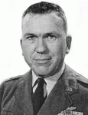
Hawai‘i Air National Guard’s Colonel Walter Foulke Judd, is credited with recreating the ceremonial Royal Guard unit, saving the ‘Iolani Barracks and early restoration of ‘Iolani Palace. The 1940 enlistee of the Hawai‘i Army National Guard’s Company K, 299th Infantry (Moloka‘i) served in World War II’s European Theatre as a decorated Army Air Corps navigator.
He was an original member of the new post-World War II Hawai‘i National Air Guard and a prolific writer of Hawaiian history. Known by many as “Papa” Judd, he passed away on November 20, 2000.
Col Walter Judd, 1960

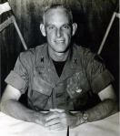
Colonel Francis Andrew Imaikalani “Miki” Bowers Jr.
Dr. “Miki” Bowers was a former commander of the 29th Infantry Brigade and first commander the 1st Battalion, 487th Field Artillery.
The Hawai‘i Guard activated-Vietnam veteran, worked at his Punahou alma mater for 40 years as a mathematics instructor and department chair. Miki Bowers passed away on January 1, 2011.
Read more on Miki Bowers http://retireenews.wordpress.com/2014/04/12/bowers/
COL "Miki" Bowers

Related:
Hawaii National Guard: http://dod.hawaii.gov/
Punahou School: http://www.punahou.edu/

