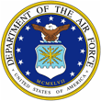 |  | 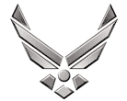

U N I T E D S T A T E S A I R F O R C E
COLONEL JEFFERY T. NAMIHIRA

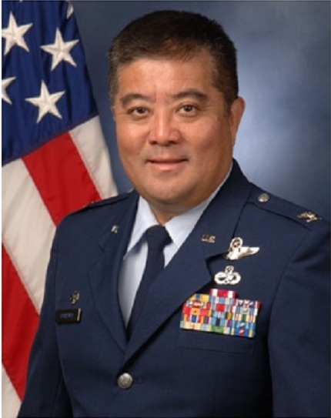
Colonel Jeffrey T. Namihira is the Commander, 154th Maintenance Group in the 154th Wing located at Joint Base Pearl Harbor-Hickam, Hawaii. He is responsible for over 900 maintenance professionals and all direct maintenance support for projected 41 assigned aircraft comprised of F-22, KC-135, and C-17 weapon systems. The 154th Maintenance Group is the largest in the Hawaii Air National Guard. In February 2006, the C-17 Globemaster III aircraft became the first associate unit; a partnership with the 15th Maintenance Group and the Hawaii Air National Guard setting the standard for the newly engaged F-22 Raptor associate unit.

Colonel Namihira graduated from Hilo High School, Hawaii in 1977. He earned his Associates in Science from Honolulu Community College in Aircraft Maintenance in 1980; majored in Education and Aircraft Maintenance and earned a Bachelor of Science Degree from University of Hawaii in 1986. He has worked in the commercial aircraft maintenance industry from avionics to heavy maintenance for over a decade.

Colonel Namihira enlisted in the Hawaii Air National Guard in February 1980. He received his commission as a second lieutenant in May 1987 through the Air National Guard’s, Academy of Military Science in Knoxville, Tennessee. He attended the Squadron Officer School in-residence and completed Air Command & Staff College and Air War College by correspondence. Colonel Namihira has commanded the 154th Operations Support Flight, 199th Fighter Squadron, and 154th Aircraft Maintenance Squadron and served as the Deputy Commander of 154th Maintenance Group.

EDUCATION:
1980 |  |  | Associate in Science, Honolulu Community College Honolulu, HI
1985 |  |  | Bachelors of Education Degree, University of Hawaii Manoa, Honolulu, HI
1986 |  |  | Post-bachelor's certificate, University of Hawaii Manoa, Honolulu, HI
1987 |  |  | Academy of Military Science ANG Commissioning Program
1987 |  |  | Undergraduate Pilot Training, Columbus AFB, MI
1987 |  |  | Fighter Lead-in, Holloman AFB, NM
1988 |  |  | F-15 Replacement Training Unit (RTU), Tyndall AFB, FL
1995 |  |  | Squadron Officer School (Residence), Maxwell AFB, AL
2000 |  |  | Air Command and Staff College (Correspondence)
2009 |  |  | Air War College (Correspondence)
ASSIGNMENTS:
1. |  | Feb 1980 – Apr 1987 Communications and Navigation System Technician F-4 Phantom, Hickam AFB, HI
2. |  | March 1987 – May 1987 Academy of Military Science, Knoxville, TN
3. |  | May 1987 – Apr 1988 Undergraduate Pilot Training, Columbus AFB, MS
4. |  | May 1988 – Jul 1988 Fighter Lead-in, Holloman AFB, NM
5. |  | Oct 1988 – Mar 1989 Replacement Training Unit (RTU), Tyndall AFB, FL
6. |  | Mar 1989 – May 2003 Fighter Pilot (HIANG), Hickam AFB, HI
7. |  | Jun 2003 – Nov 2005 Chief of 154th Wing Weapons (HIANG), Hickam AFB, HI
8. |  | Dec 2005 – Jan 2008 Commander, 154th Operations Support Flight, Hickam AFB, HI
9. |  | Jan 2008 – Dec 2009 Commander, 199th Fighter Squadron, Hickam AFB, HI
10. |  | Dec 2009 – Oct 2010 Commander, 154th Aircraft Maintenance Squadron, Hickam AFB, HI
11. |  | Nov 2010 – Feb 2011 Deputy Commander, 154th Maintenance Group, Hickam AFB, HI
12. |  | Mar 2011 – Present Commander,154th Maintenance Group, Joint Base Pearl Harbor Hickam, HI
 | MAJOR AWARDS AND DECORATIONS:
 | Meritorious Service Medal
 | Air Force Commendation Medal
 | Air Force Achievement Medal
 | Air Force Outstanding Unit Award with Valor Device
 | Combat Readiness Medal
 | Air Reserve Forces Meritorious Service Medal
 | National Defense Service Medal
 | Armed Forces Expeditionary Medal
 | Southwest Asia Service Medal
 | Global War on Terrorism Service Medal
 | Humanitarian Service Medal
 | Armed Forces Reserve Medal
 | ACHIEVEMENTS: Outstanding NCO of the Year
 | Outstanding Officer of the Year
 | Outstanding Field Grade of the Year
 | 199th Fighter Squadron Fighter Pilot of the Year
 | 199th Fighter Squadron Most Impact
 | Hawaii National Guard Association Officer of the Year
 | 613th Air Operations Center/Combat Plans Division Outstanding Performer
 | EFFECTIVE DATES OF PROMOTIONS:
 | Second Lieutenant |  |  |  |  | 21 May 1987
 | First Lieutenant |  |  |  |  | 21 May 1990
 | Captain |  |  |  |  | 28 January 1993
 | Major |  |  |  |  | 28 January 2000
 | Lieutenant Colonel |  |  |  |  | 16 December 2005
 | Colonel |  |  |  |  | 15 July 2011

(Current as of 26 January, 2012)

