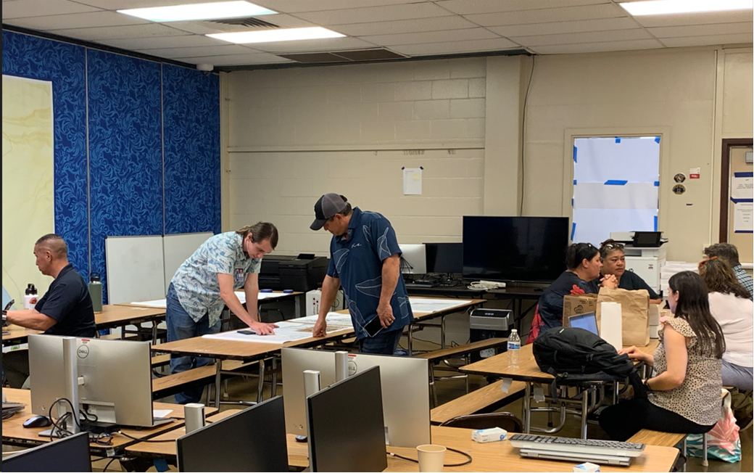
1/31/2024 HIEMA’s Zeph McKee meets with security contractor Ka’ala Buenconsejo regarding traffic route changes in / around the burn zone.
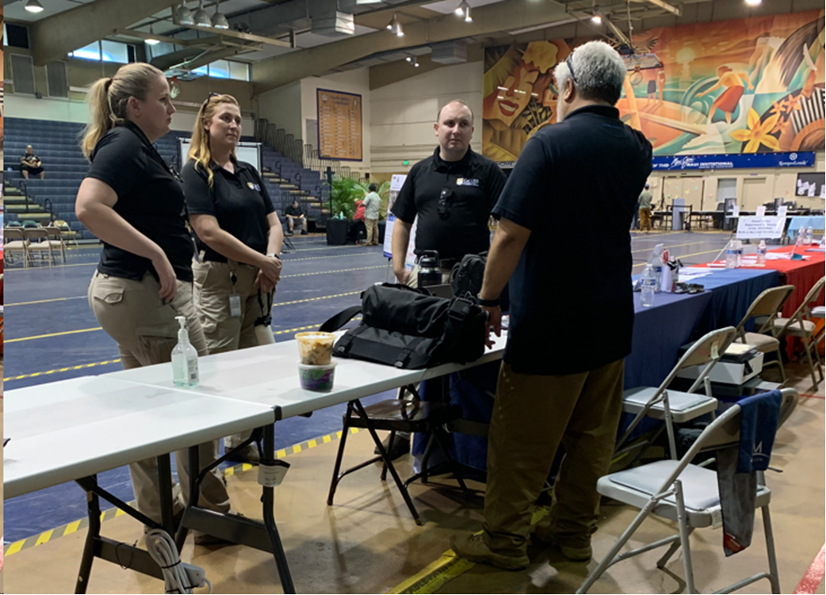
1/31/2024 HIEMA Executive Officer Don Aweau discusses cost share requirements with the Cal OES team before the Lahaina community meeting.
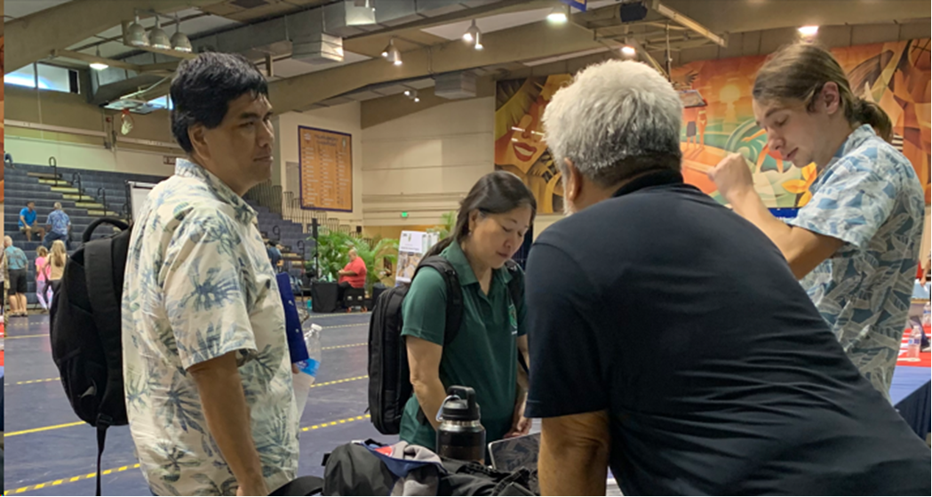
1/31/2024 DOH’s Joanna Seto stopped by to introduce DOH’s Glenn Haae to HIEMA’s Don Aweau and Zeph McKee. Glenn has been involved with Debris Task Force related meetings for months but the team had not had an opportunity to meet face to face until today.

